Pros and Cons of Admissions Tests
INTRODUCTION
Debate about the use of standardized testing for student selection has persisted for decades. In May 2020, the University of California Board of Regents unanimously voted to suspend standardized testing requirements for all freshmen applications until fall 2024, with plans to design a new admissions test that better aligns with the content the University expects students to have mastered for college readiness. The following list represents common arguments for and against the use of standardized admissions tests for entrance into college and university degree programs (e.g. SAT, ACT, GRE, PCAT). This information was requested by Olivia Hammill to help facilitate discussion among the School’s Admission and Recruitment Committee about the use of the PCAT.

Common Arguments FOR Use
- Enables sorting of candidates based on a standardized assessment
- Provides some insight into likelihood of student performance in didactic coursework early in a curriculum
- Low resource for institutions to use for admissions decisions (e.g. doesn’t require institution to administer additional test/assessment)
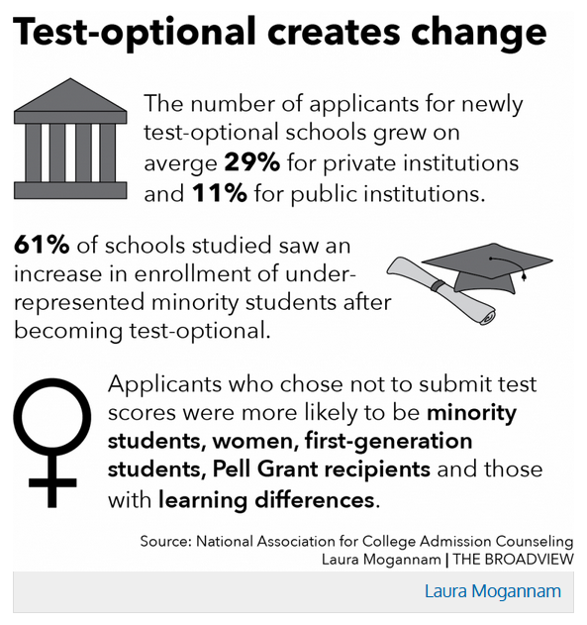
Common Arguments AGAINST Use
- Apparent testing bias against some cultural, ethnic, and socio-economic groups (e.g. cultural assumptions)
- Costs associated with registering and preparing for the test may serve as a deterrent
- Predictive validity diminishes over time (e.g. less predictive of performance later in a curriculum) – currently no evidence that test-optional negatively affects graduation rates
- Scores can lack reliability, particularly given environmental factors or emotional stress
- Tests reward quick thinking, not deep or creative thinking
- Scores are poor measures of student achievement, particularly the ability to understand and apply complex material
- Other types of assessments may provide information that is better aligned with curriculum
https://broadview.sacredsf.org/14643/news/institutions-open-doors

Examples of PCAT Research
(NOTE: most PCAT research lacks generalizability due to single institution design, therefore results of studies should be interpreted with caution)
- PCAT generally has predictive validity early in a curriculum; this can vary by PCAT section (e.g. PCAT-Chemistry is a stronger predictor than others)
- Most PCAT correlations with student achievement in pharmacy school tend to be moderate or weak and explain a low percentage of variance in scores
  - e.g. From Williams et al 2019: Regression models were significant but explained a low percentage of the variance in OSCE scores
- Predictive validity tends to diminish over time and other factors are more predictive of long-term outcomes
  - APPE SCORES. From Heldenbrand et al 2017: MMI more strongly correlated with APPE scores (r_{p} = .24) than PCAT (r_{p}=.08).
  - ON-TIME GRADUATION/DISMISSAL. From Spivey et al 2019: PCAT composite percentile not a significant predictor of on-time graduation (predicted by age, undergraduate degree, and PY1 GPA) or dismissal (predicted by PY1 GPA).
  - RESIDENCY MATCHING. From Feemster et al, 2017: In the multivariable analysis, PCAT-Chemistry (OR = 0.979, p = 0.0455), PCAT-Reading Comprehension (OR = 1.012, p = 0.0428), and final grade point average (OR = 9.847, p < 0.001) were significantly associated with match success.
  - MJPE PASS RATE. From Mospan et al 2020: There were no significant associations between NC MPJE scores and … Pharmacy College Admission Test scores.
  - LICENSURE EXAMS. From Cameron et al 2017: The PCAT, pre‐pharmacy GPA and age significantly predicted the [Pharmacy Examining Board of Canada-PEBC] -MCQ overall score. The MMI was the only significant predictor of overall score on the PEBC –OSCE (β = 0.17, p = 0.02).

REFERENCES and RESOURCES
Cameron, A. J., MacKeigan, L. D., Mitsakakis, N., & Pugsley, J. A. (2017). Multiple mini‐interview predictive validity for performance on a pharmacy licensing examination. Medical education, 51(4), 379-389.
Evans, B. (2015). College Admission Testing in America. In Stead, V. (Ed.), International Perspectives in Higher Education Admission Policy: A reader. New York: Peter Lang Publishing.
Feemster, A., Calabrese, M., Gaitonde, P., & Shaya, F. (2017). Characteristics of Pharmacy Students Associated with a Successful PGY1 Residency Match. Medical Science Educator, 27(4), 607-611.
Heldenbrand, S. D., Dayer, L. E., Martin, B. C., O’Brien, C., Choi, A. N., Gubbins, P. O., ... & Flowers, S. K. (2018). APPE Evaluations are Positively Associated with MMI, Pre-pharmacy GPA and Pharmacy GPA. American journal of pharmaceutical education, 82(7).
Mogannam, L. (2018). Test-optional creates change. Accessed June 3, 2020 from https://broadview.sacredsf.org/14643/news/institutions-open-doors
Mospan, G., Gillette, C., & Mospan, C. M. (2020). Predictors of performance on the North Carolina Multistate Pharmacy Jurisprudence Examination. Currents in Pharmacy Teaching and Learning, 12(1), 35-40.
Soares, J. A. (2015). SAT wars: The case for test-optional college admissions. Teachers College Press.
Spivey, C. A., Chisholm-Burns, M. A., & Johnson, J. L. (2019). Factors Associated with Academic Progression and NAPLEX Performance Among Student Pharmacists. American Journal of Pharmaceutical Education.
UC Office of the President (2020). University of California Board of Regents unanimously approved changes to standardized testing requirement for undergraduates. Accessed June 3, 2020 from https://www.universityofcalifornia.edu/press-room/university-california-board-regents-approves-changes-standardized-testing-requirement
Williams, J. S., Metcalfe, A., Shelton, C. M., & Spivey, C. A. (2019). Examining the Association of GPA and PCAT Scores on Objective Structured Clinical Examination Scores. American Journal of Pharmaceutical Education, 83(4).

