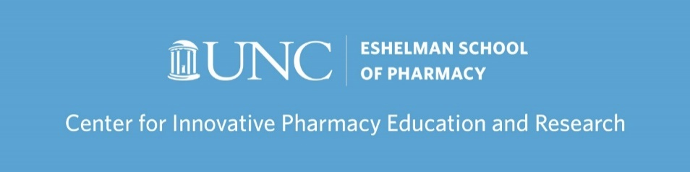

CIPhER Programs & Events - 2018–2019

CIPhER Fridays
Growth Mindset, Lana Minshew, October 26, 2018, 1-2:30 pm
Preparing Students to Communicate about Sensitive Topics with Patients, Lesha Carpenter, November 16, 2018, 1-2:30 pm
A Lightning Round of Innovative Pharmacy Teaching, Assessment, and Education Research, Various School Personnel, December 14, 2018, 1-3 pm
The Future of Interprofessional Education at UNC, Phil Rodgers, January 11, 2019, 12-1:30 pm
Multiple Choice Questions: Do Yours Make the Cut?, Mari-Wells Hedgpeth (NCSU College of Veterinary Medicine), January 18, 2019, 3-4:30 pm
Cross Cultural Classroom Engagement: Perspectives from the Health Science Schools, Carla White, March 1, 2019 [postponed due to School conflict].
Learning Analytics: Using Course Data to Contribute Towards Student Success, Matthew Bernacki, (UNC School of Education), Michael Wolcott, Robert Plumley (UNC School of Education), March 29, 2019, 12-1:30pm
A Lightning Round of Innovative Pharmacy Teaching, Assessment, and Education Research, Various School Personnel, May 17, 2019, 12-2 pm

Teaching Assistant (TA) Orientation
TA Orientation #1, Amber Frick, August 10, 2018, 12:30–3:30 pm
TA Orientation #2, Jessica Greene, September 21, 2018, 12:30–3:30 pm

Teaching & Learning Certificate Program (TLC; formerly Resident Teaching Certificate Program)
TLC Colloquium #1, Jessica Greene, Amber Frick, Nikki Lobczowski, September 7, 2018, 1–2:30 pm
TLC Colloquium #3, Jacqui McLaughlin, Amber Frick, May 24, 2019, 12–3 pm

Facilitator Training Program
Facilitating Small Groups to Promote Learning and Collaboration, Jacqui McLaughlin & Lana Minshew, January 3, 2019, 10–11 am

Pharmacy Education and Research Community (PERC)
AACP 2018 Debrief, Michael Wolcott, August 27, 2018, 9–10 am
Self-Care and Strategic Planning, Michael Wolcott, September 18, 2018, 12-1:30 pm

Visiting Scholars
Entrustable Professional Activities (EPAs) for Health Professions Training, Olle (Th.J.) ten Cate (University Medical Center Utrecht, The Netherlands), February 12, 2019, 12-1:30 pm
Are You a Fair Grader? Ways to Improve Assessment of Student Performance, Kenneth Royal (NCSU College of Veterinary Medicine), April 26, 2019, 12-1:30 pm

2019 Summer Institute
Evidence-based Teaching and Course Design, Jacqui McLaughlin, Ken Royal, Tom Angelo, Michelle Farland, May 20-23, 2019, 8:30 am-4 pm, UNC Rizzo Center

CIPhER Programming, Added in 2018-2019
Carolina Cancer Nanotechnology T32 Training Program [added in 2018-2019]
How to Design a Course and Syllabus, Amanda Olsen, September 10, 2018, 11:30 am–12:50 pm
How to Utilize a Flipped Classroom, Lana Minshew, September 24, 2018, 12–1:30 pm
Collaborative Project-Based Learning, Lana Minshew, February 25, 2019, 12:15-1:45 pm
Creating Authentic Assessments, Amanda Olsen, March 4, 2019, 12:15-1:45 pm

Preceptor Design Lab Series, a Collaboration [added in 2018-2019]
Engineering Your Practice Experiences and Activities to Elevate Every Level of Learner, Charlene Williams, Kayley Lyons, Ian Hollis (UNC Hospitals), Jessica Sinclair (Rx Clinic Pharmacy), Irene Ulrich (MAHEC), November 9, 2018, 12-1:30 pm
Feedback Finesse – Fine-Tuning Feedback for Quality, Charlene Williams, Laura Sjoquist, Michael Wolcott, Brian Donahue, Kathryn Fuller, May 8, 2019, 12-1 pm

Masterclass Sessions [added in 2018-2019]
Incorporation of EPAs Across the Curriculum for Assessment of Student Competency, Olle (Th.J.) ten Cate (University Medical Center Utrecht, The Netherlands, February 12, 2019, 11:45 am-2 pm
Student Wellness and Assessment in Health Professions Education, Kenneth Royal (NCSU College of Veterinary Medicine), April 26, 2019, 2:30-4 pm

Curriculum Focused Hands-On Workshops [added in 2018-2019, in collaboration with Office of Curricular Innovation]
Won’t You Take Me to…OSCE-Town! A Hands-On OSCE Workshop, Amanda Savage, May 9, 2019, 9 am-4 pm
Multiple Choice Questions: Do Yours Make the Cut? A Hands-On Workshop, Mari-Wells Hedgpeth (NCSU College of Veterinary Medicine), May 10, 2019, 8:30 am--2:00 pm

Rx Writing Challenge [added in 2018-2019]
Fall 2018 Rx Writing Challenge, Kayley Lyons, October 15-26, 2018, 8–9 am
Spring 2019 Rx Writing Challenge, Lana Minshew, March 31-April 13, 2019, 8-10 am

